**Simply Succulent SLPS**

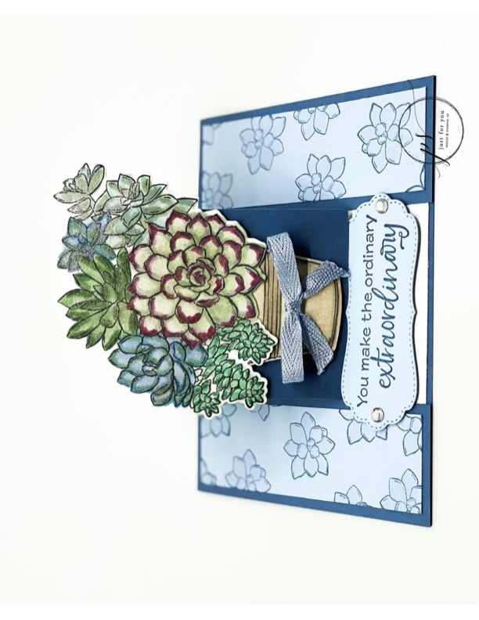

All images © 1990-2021Stampin’ Up!®

**Supplies**:

* **Stamp Sets *–*** Simply Succulents Bundle (156264)
* **Card Stock** – Basic White (159276); Misty Moonlight (153081); Seaside Spray (150883)
* **Stamp Pads** – Memento Tuxedo Black (132708); Misty Moonlight (153118)
* **Misc**. – Stampin’ Blends Combo Packs: Balmy Blue (154830), Bermuda Bay (154878), Crumb Cake (154882), Highland Heather (154887), Just Jade (153107), Mint Macaron (154889), Mossy Meadow (154890), Night of Navy (154899), Pool Party (154894), Purple Posy (154896), Rich Razzleberry (154898), Seaside Spray (154901), Soft Sea Foam (154902); Wink of Stella Glitter Brush (141897); Rhinestone Basic Jewels (144220); Seaside Spray ¼” Metallic Ribbon (150446); Stampin’ Seal (152813); Stampin’ Dimensionals (104430); Glue Dots (103683); Stampin’ Cut & Emboss Machine (149653)

**Measurements**:

* Misty Moonlight CS: 5-1/2” x 8 –1/2”, scored at 4 -1/4”. Cut at the 1-1/2” up to the 4 1/4 score line. Rotate 180° and cut again at the 1-1/2” up to the 4-1/4” score line. Take the middle piece & score at 2-1/8” .
* Seaside Spray CS: 2 Strips 1-1/4” x 4”, scrap for sentiment
* Basic White: 5 -1/4” x 4”, scrap for flower pot 1”x1-1/2” & 3”x3” for large succulent image.

**Instructions:**

1. Stamp large Succulent flower with Memento Tuxedo Black onto Basic White Cardstock.
2. Stamp flowerpot with Memento Tuxedo Black onto Basic White Cardstock.
3. Stamp Sentiment with Misty Moonlight onto Seaside Spray Cardstock.
4. Stamp small succulents randomly onto the 2 Seaside Spray strips with Misty Moonlight.
5. Adhere the Seaside Spray strips to both flaps. Fill in flowers with Wink of Stella Glitter Brush.
6. Stamp your sentiment with Misty Moonlight to top middle of the 5 -1/4” x 4” Basic White CS & adhere to the inside of card.
7. Now glue down your flaps onto the Basic White.
8. Let’s start blending. Starting with the main succulent – use Mint Macaron Light, color the whole flower, then come in with the Mint Macaron Dark & and mark the lines, then come back in with the light to blend. Then come Rich Razzleberry Dark & color all the borders. Take Purple Posy light & blend. Repeat process for each succulent using colors of choice listed above.
9. Once all colored, add your Wink of Stella Glitter Brush to entire image.
10. Using Crumb Cake light color the whole flowerpot. Now come in with the dark & mark all the lines as well shade both sides of pot but leave about ¼ ‘ then come back in with the light.
11. Using the large succulent die, line up over stamped succulent image, the sentiment die centered over sentiment and pot die over stamped pot run all thru the Stampin’ Cut & Emboss Machine at same time. This saves steps.
12. Add Stampin’ Dimensionals to the flowerpot, the sentiment & only bottom of large succulent.
13. Adhere the sentiment to the bottom middle of the Basic White (this is your stopper).
14. Adhere the flowerpot and large succulent to the bottom front of the Misty Moonlight CS.
15. Using a glue dot, adhere bow to flowerpot.
16. Add Rhinestone Basic Jewels to both sides of the sentiment.